**WFM Documentation for EDCAR Project – development, testing & integration of data models, deployment and maintenance**

Content

1. Introduction 1

1.1 List of credentials 2

1.2 List of Databases 3

1.3 Development Phase 3

2. REPODB Data Load 4

2.1 Test Scenarios 4

2.2 Scheduling 4

2.3 Load Report 4

2.4 Graphical Model 6

2.5 Production Scenario 7

3. Cepres Bulk Data Load 7

3.1 Test Scenarios 7

3.2 Scheduling 8

3.3 Load Report 8

3.4 Graphical Model 10

3.5 Production Scenario 12

4. Deployment to Production 13

5. Next Steps 14

6. Error Logs after Data Load 15

7. List of Potential Errors in WFM & Solutions 17

# Introduction

Workflow Manager (WFM) is UI Labs – developed ETL Tool (extract, transform, load).

WFM is used to semi-automate and automate EDCAR Data Load Transfer. It uses a triggering mechanism to perform a data load and executes all steps of EDCAR “Load”. At the end it delivers an automated audit report of the Load.

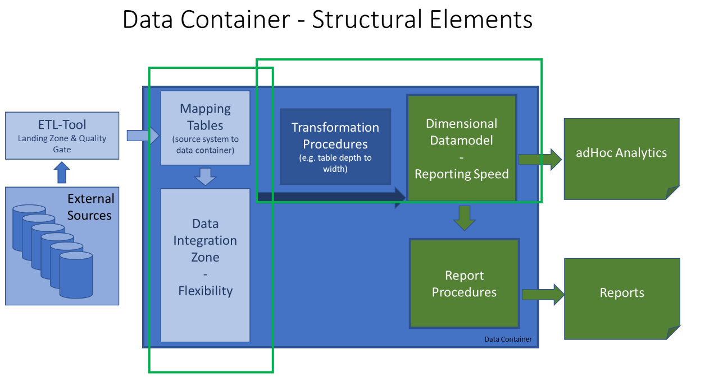Please note WFM does not transform any data but solely triggers the mechanism that is embedded into the Data Container.

*Form 1. EDCAR - Data Architecture -in red box marked WFM “ETL – Tool”*

## List of credentials

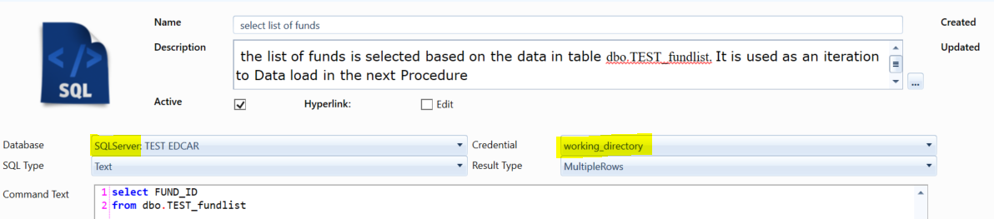When running test make sure following credentials are set for you:

|  |  |  |  |
| --- | --- | --- | --- |
| Environment | Database | Credentials | Authentication Type |
| TEST | SQLServer: TEST EDCAR | xyz |  |
| TEST | Oracle: REPOTES1 | xyz |  |
| PROD | SQ Server: EDCAR Production | xyz |  |
| PROD | Oracle: REPO | xyz |  |

*Form 2. Example Credentials in WFM*

For any credentials setup that require password please contact:

xyz

## List of Databases

|  |  |  |
| --- | --- | --- |
| Environment | Database | Status |
| TEST | SQL Server: TEST EDCAR | active |
| TEST | Oracle: REPOTES1 | active |
| DEV | SQL Server: DEV_EDCAR | outdated |
| DEV | Oracle: RepoDev2 | outdated |
| PROD | SQL Server: EDCAR Production | active |
| PROD | Oracle: REPO | active |

## Development Phase

All Data Flows developed are considered an end Product delivered as a result of EDCAR Implementation Plan. In general, it consists of below phases:

1. Planning
2. Analysis
3. Design
4. Implementation
5. Testing & Integration
6. Maintenance

# REPODB Data Load

## 2.1 Test Scenarios

For REPODB Load we assume only one single test scenario where we load all fund_id stored in *\\ui.net\Konzern\Projekte\UI_Ambition_Reporting\Workstream_AI\03 Development\WorkingDirectory\WFM_Test*

to EDCAR_DIZ and EDCAR_DDM providing a Load Report. We do not perform a partial load. It means that even if the Load returns errors (based on the Load Report) it is completed, and all data transferred to DDM. In case of errors, one must go back to DIZ Load Report and based on issues identified tackle errors in a separate request (User Story etc.). then launch a new load.

Ad hoc REPODB Loads e.g. partial loads can be developed in the future.

## 2.2 Scheduling

You can use Scheduler developed by UI Labs to schedule your Data Load Sessions.

To create a new schedule, follow the steps below:

* Select “New Schedule”:

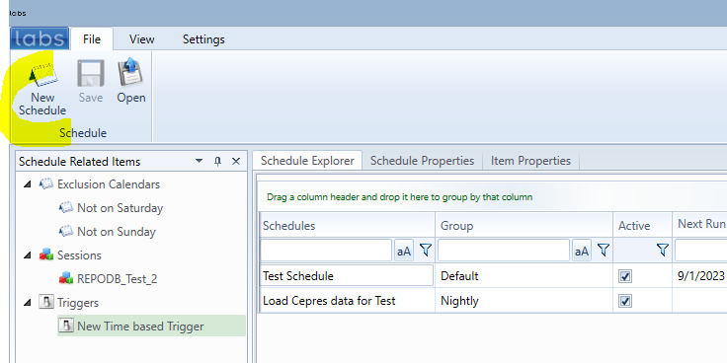

* define criteria

## 2.3 Load Report

After each Load is complete, a Load Report is sent to a List of Recipients

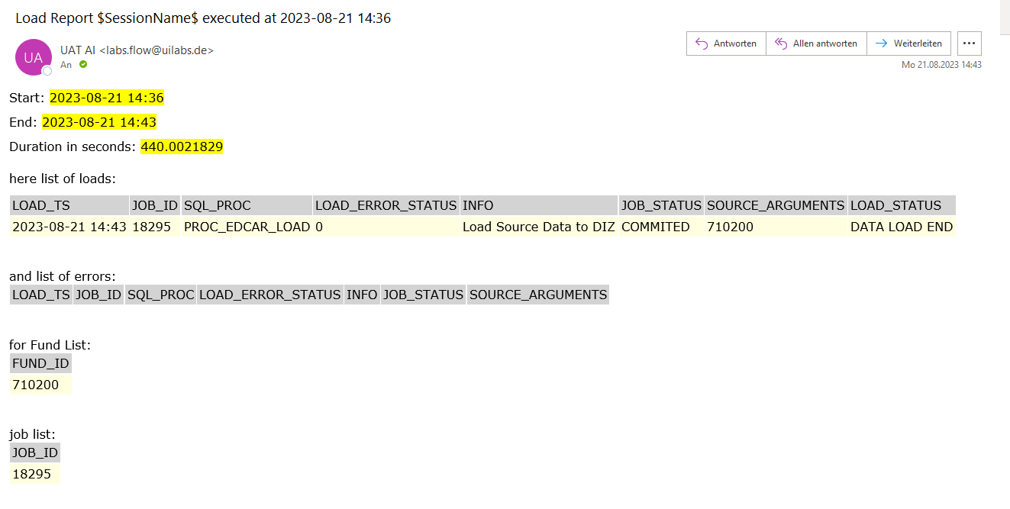

In the future you can setup Load Reports to be saved in a separate folder using Endpoints and Load Data Task:

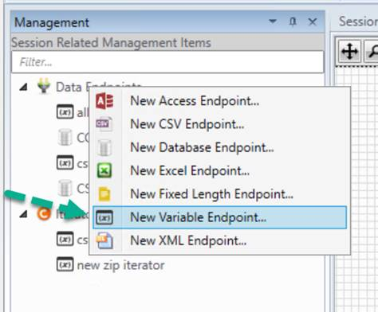

There you chose your correlation List Variable:

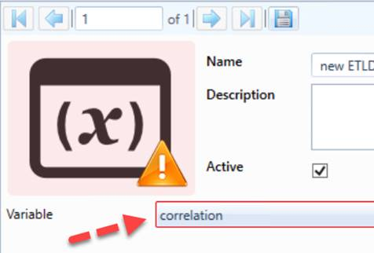

After that you can insert a new Load Data Task to your Workflow and from where you can write your Log to any destination endpoint you want (i.e. csv or excel).

## 2.4 Graphical Model

**Step 1**. load the list of Funds into a Data Endpoint in WFM from an excel file saved here: \\ui.net\Konzern\Projekte\UI_Ambition_Reporting\Workstream_AI\03 Development\WorkingDirectory\WFM_Test. Next, they are saved in Table dbo.TEST_fundlist (TEST_EDCAR)

**Step 2**. Record the Start_Timestamp of Load to DIZ (with commitment). It will be used to calculate the End_Timestamp of the Load.

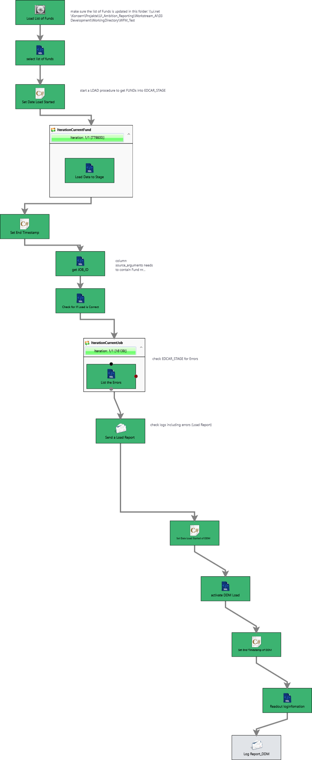

**Step 3**. Start EDCAR Procedure to Load Data to DIZ (with commitment) in an Iteration – loading single Fund from the List of Funds in Table dbo.TEST_fundlist (TEST_EDCAR)

**Step 4**. Record the End_Timestamp and the duration of the Load

**Step 5**. Get JOB_ID for each Load that occurred in this iteration based on the condition that the LOAD_TS in Table ='$End_Timestamp$' AND [LOAD_STATUS] = 'DATA LOAD END' AND [SOURCE_SYSTEM_ID] = 1

**Step 6**. Check if the Load is correct looking at the Tables [EDCAR].[SOURCE_LOAD_LOG] and [EDCAR].[SOURCE_LOAD_JOB]

**Step 7**. Check for Errors looking at the Tables [EDCAR].[SOURCE_LOAD_LOG] and [EDCAR].[SOURCE_LOAD_JOB]

**Step 8**. Send the Load Report to dedicated Email List (to be defined) that includes below Information: Start_Timestamp, End_Timestamp, Duration, List of Loads, JOB_ID List, FUND_ID List, List of Errors

**Step 9**. Record the Start of Load to DDM as Start_Timestamp_DDM

**Step 12**. Read Log information and send a report to dedicated Email List

**Step 11**. Record the End of Load to DDM as End_Timestamp_DDM

**Step 10**. Run active DML

## 2.5 Production Scenario

In Production Scenario we load all fund_id stored in

N:\Projekte\UI_Ambition_Reporting\Workstream_AI\10_Production

Corresponding Table in Microsoft Server Studio is saved as [EDCAR].[dbo].[fundlist]

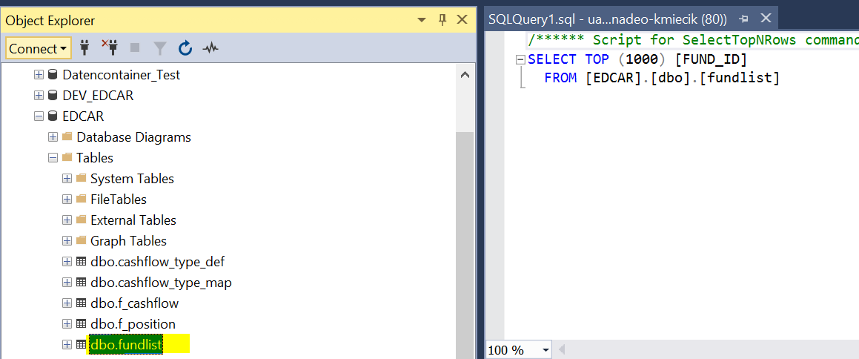

Data Model deployed in Production WFM:

“*Dataload REPODB*”



# Cepres Bulk Data Load

## Test Scenarios

We assumed 4 test scenarios. The first one loads CSV Files from zip files (must first unzip them) and uploads CSV paths to SQL Server. This model truncates all the source tables and hence has no historisation. Second model, with a similar approach stores historical data (but only zip historical data in the table [EDCAR].[SOURCE_LOAD_CONTROL_COMPARE_ZIP] ). Third model serves to upload specific csv files directly to the SQL server. It is used in case we had some csv files from previous loads that have not been loaded or had errors. The last model is used to perform a partial load – in case of technical issues with WFM Bulk Load can me performed semi-manually in SQL Server using SQL command.

Use the workflow called "20230926_TEST_only_csv_cepres_to_EDCAR.flow ". First place the csv files in the \ui.net\uilabs\UAT\AI\Cepres\Working_directory directory and run the workflow. The csv file names and paths will be uploaded to [EDCAR.SOURCE_LOAD_CONTROL_CSV_DATA_PATH].

|  |  |  |
| --- | --- | --- |
| Scenario / Conditions | Data Flow Name | Steps |
| Bulk Load of zip files without historisation, loads all files | 20230926_TEST bulk load_cepres_to_EDCAR_V5.flow | Place the zip files in the *\\xyz\uilabs\UAT\AI\Cepres\test* |
| Bulk Load of zip files without historisation, loads all files | 20230926_TEST bulk load_cepres_to_EDCAR_V3.flow | Place the zip files in the *\\xyz\uilabs\UAT\AI\Cepres\test* |
| Load of Single CSV Files (usually performed when previously not loaded) | 20230926_TEST_only_csv_cepres_to_EDCAR.flow | Place the csv files in the \xyz\uilabs\UAT\AI\Cepres\Working_directory |
| Partial Load (unzipping and inserting file paths to EDCAR.SOURCE_LOAD_CONTROL_CSV_DATA_PATH) | 20230926_TEST bulk load_cepres_partial.flow | Place the zip files in the *\\xyz\uilabs\UAT\AI\Cepres\test* |

## Scheduling

You can use Scheduler developed by UI Labs to schedule your Data Load Sessions.

## Load Report

After each Load is complete, a Load Report is sent to a List of Recipients :

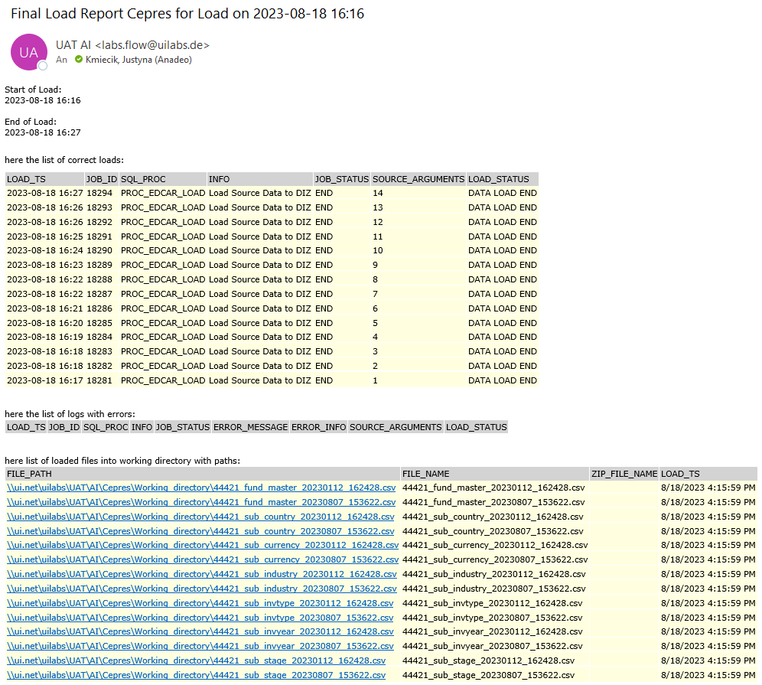

Email Recipient List is:

[xyz](mailto:reporting_data_mgmt@universal-investment.com)

## Graphical Model

Part 1. Bulk_Load_Cepres_to_EDCAR_Data Model (Bulk Load of zip files without historisation, loads all files)

**Step 9.**

**Step 9.** Get a list of correct loads and errors and send a Report to a dedicated list of emails (to be defined)

**Step 8.**

**Step 4**. Loop through new zip files in an iteration and unzip them into the folder: \\ui.net\uilabs\UAT\AI\Cepres\Working_directory

**Step 5**. List csv files unzipped from the files into the folder: \\ui.net\uilabs\UAT\AI\Cepres\Working_directory

**Step 7**. Load csv files into the Table [EDCAR].[SOURCE_LOAD_CONTROL_CSV_DATA]

**Step 6**. Load csv files into the Table [EDCAR].[SOURCE_LOAD_CONTROL_CSV_DATA]

**Step 8.** Record Start_Timestamp & Bulk Load SV Files & Record End_Timestamp

**Step 7.**

**Step 6.**

**Step 3**. Load all zip files list to the Table [EDCAR].[SOURCE_LOAD_CONTROL_COMPARE_ZIP] and then find new files comparing results to the table [EDCAR].[SOURCE_LOAD_CONTROL_LOADED_ZIP]

**Step 2**. List all zip files saved in the source folder (where you insert your Cepres .zip files) *\\ui.net\uilabs\UAT\AI\Cepres\test*

**Step 1**. At the beginning of each “Load into EDCAR” we truncate tables in order to provide a clean set of tables and allow for the load of all items founds in the tables. This process can be changed (to be discussed). Tables truncated: [EDCAR].[SOURCE_LOAD_CONTROL_CSV_DATA] [EDCAR].[SOURCE_LOAD_CONTROL_LOADED_ZIP], [EDCAR].[SOURCE_LOAD_CONTROL_COMPARE_ZIP]

**Step 5.**

**Step 4.**

**Step 3.**

**Step 2.**

**Step 1.**

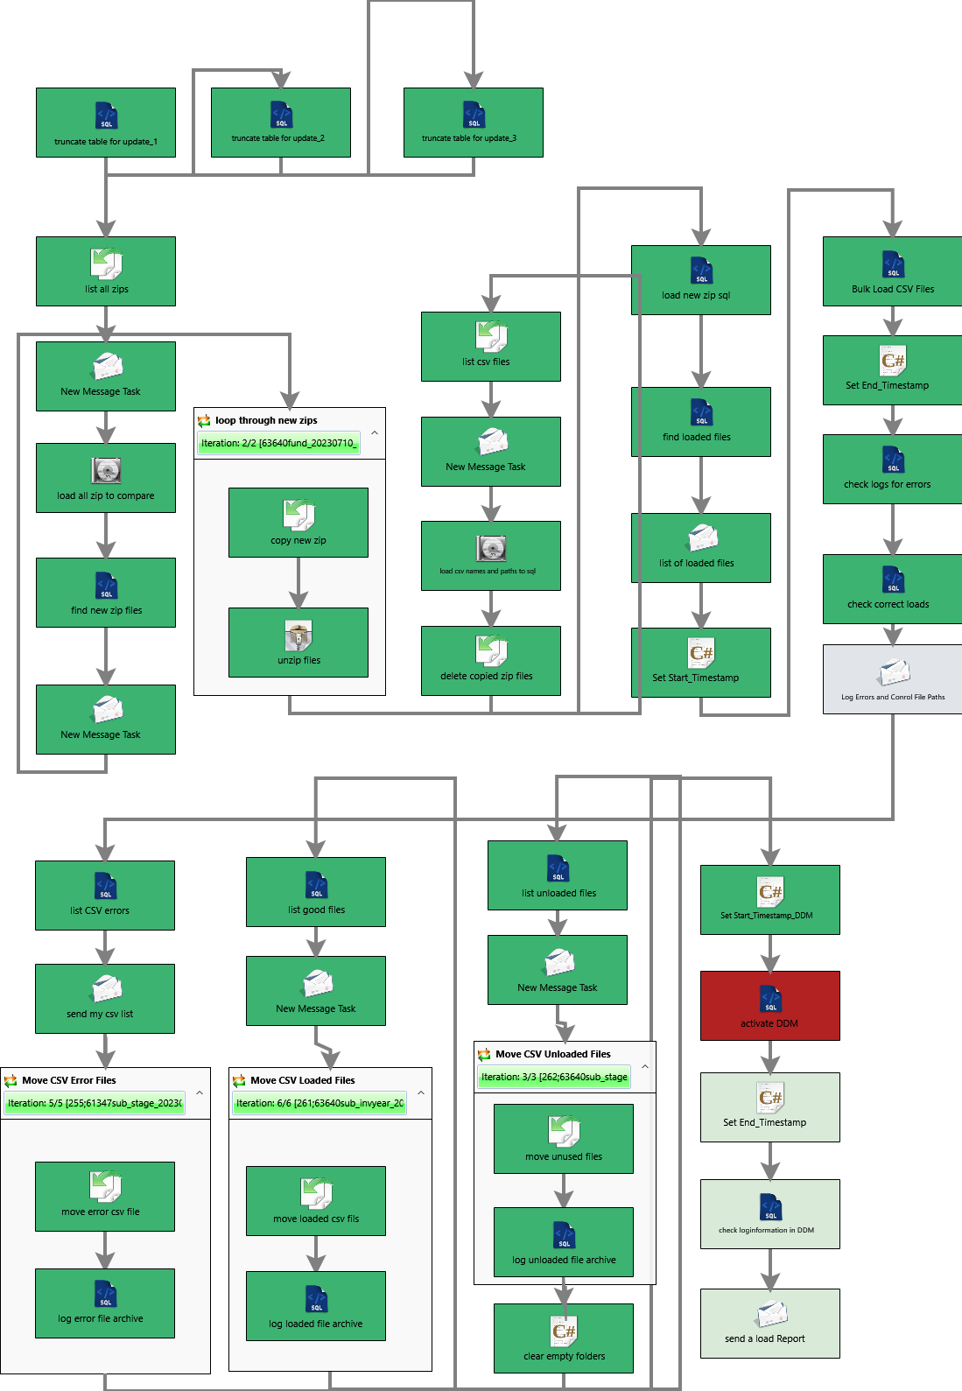

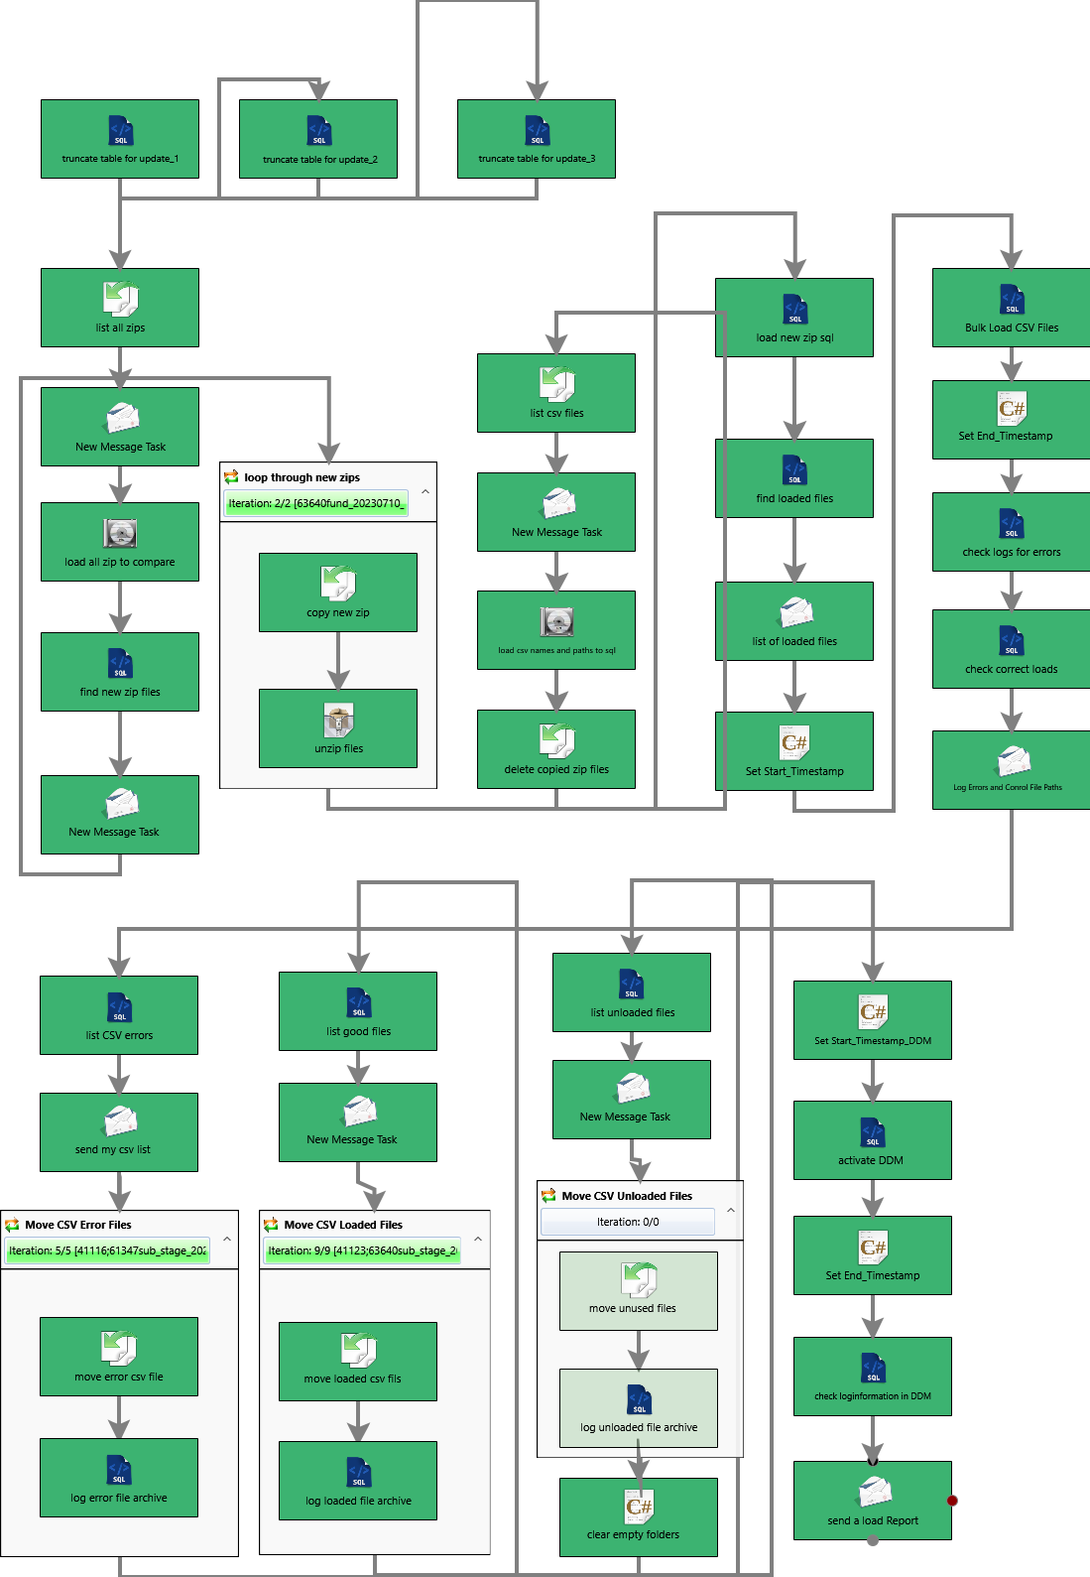Part 2. Bulk_Load_Cepres_to_EDCAR_Data Model

**Step 11.** Get a list of files correctly loaded and move them to the subfolder: *\\ui.net\uilabs\UAT\AI\Cepres\Archive*

**Step 12.**

**Step 13.**

**Step 11.**

**Step 10.**

**Step 14.**

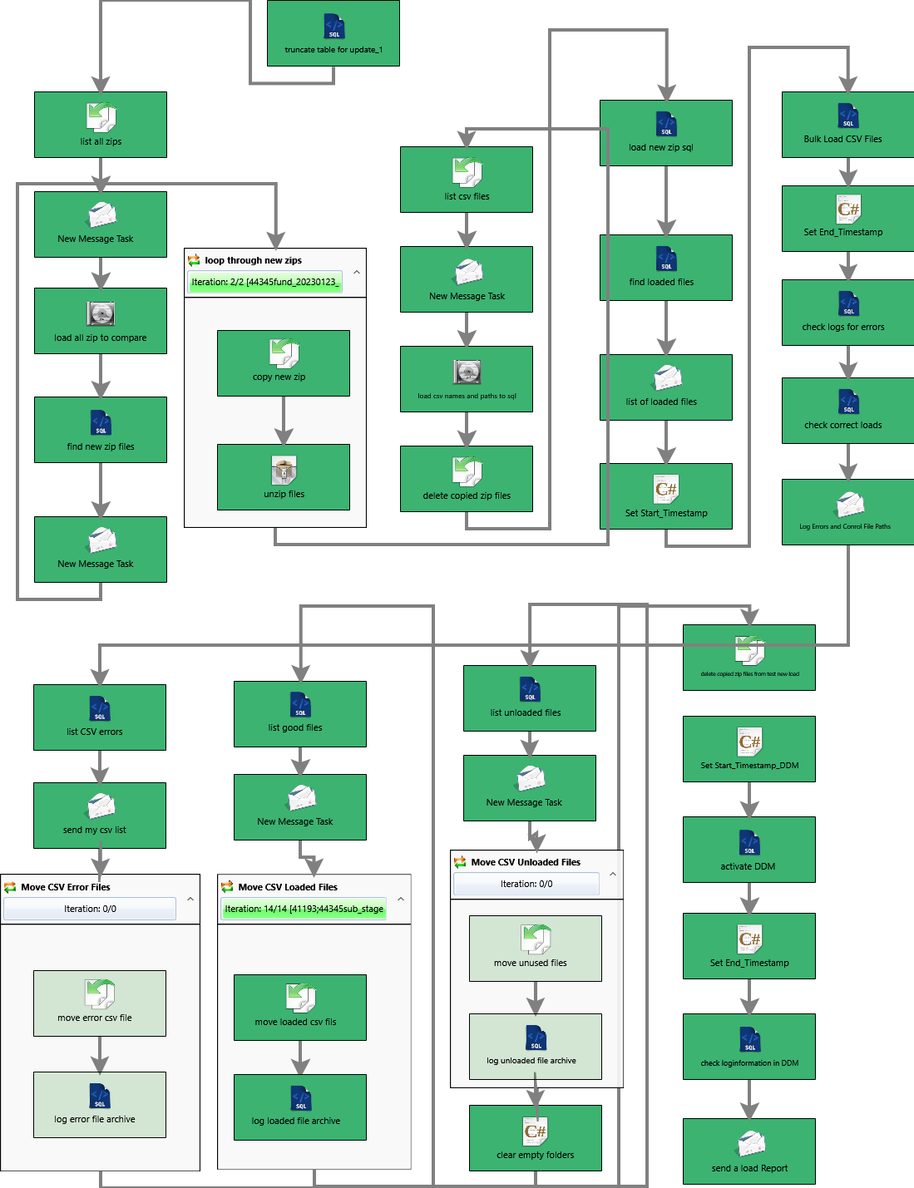

**Step 10.** Get a list of files processed with errors and move them to the subfolder: *\\ui.net\uilabs\UAT\AI\Cepres\Error*

**Step 12.** Get a list of files not loaded and move them to the subfolder: *\\ui.net\uilabs\UAT\AI\Cepres\Not_loaded*

**Step 15.**

**Step 13.** Clear folder after the load: *\\ui.net\uilabs\UAT\AI\Cepres\Working_directory*

**Step 14.** Clear folder from *zip after the load: *\\ui.net\uilabs\UAT\AI\Cepres\test*

**Step 15.** Activate a DDM Load and record a Correlation_ID, Start_Timestamp & End_Timestamp

**Step 16.**

**Step 16.** Check Log information in Table edcar_ctrl.efw_logentries based on your unique Correlation_ID

**Step 17.**

**Step 17.** Send a Report with Log Information to a dedicated list of emails (to be defined)

## Production Scenario

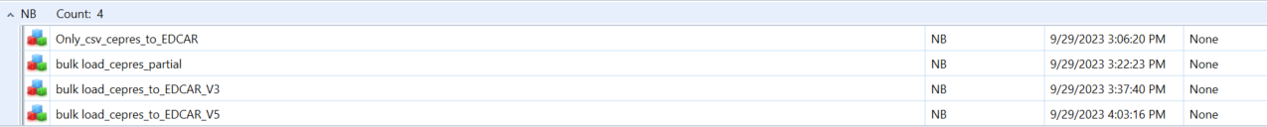Dataflows for Bulk Load Cepres have been already deployed to Production WFM. See below:

Below folders are used as a source and distribution folders for Cepres Production Data:

\\N:\Verarbeitung\RepSol\EDCAR\Inputdata

[File:\\N:\Verarbeitung\RepSol\EDCAR\Archive](File:///N:\Verarbeitung\RepSol\EDCAR\Archive)

[File:\\N:\Verarbeitung\RepSol\EDCAR\Error](File:///N:\Verarbeitung\RepSol\EDCAR\Error)

[File:\\N:\Verarbeitung\RepSol\EDCAR\Not_loaded](File:///N:\Verarbeitung\RepSol\EDCAR\Not_loaded)

[File:\\N:\Verarbeitung\RepSol\EDCAR\Working_directory](File:///N:\Verarbeitung\RepSol\EDCAR\Working_directory)

# Deployment to Production

Deployment of Data Flows into Production Environment can be executed by EDCAR Team once below Task List have been completed:

|  |  |  |  |
| --- | --- | --- | --- |
| **Task Description** | **Person Assigned** | **Task Nr.** | **Status** |
| Test in Production WFM on dummy data set connection to MSQL & Oracle DB | Justyna | [3605](https://dev.azure.com/PABIM/EDCAR/_workitems/edit/3605) | Complete |
| Access to WFM Production / Scheduler for Kuba, Marta, Maciej | xyz (UI Labs) | [3734](https://dev.azure.com/PABIM/EDCAR/_workitems/edit/3734) | Complete |
| Additional Tests for WFM Data Models – manual tests to do for Cepres Bulk Load (or check timeout settings) | xyz | [3735](https://dev.azure.com/PABIM/EDCAR/_workitems/edit/3735) | Complete |
| Add \\xyz\Konzern\Extern-Datenaustausch\CEPRES-Test as the production folder to Data Model | Justyna Kmiecik | [3736](https://dev.azure.com/PABIM/EDCAR/_workitems/edit/3736) | Complete |
| Add “Working_directory”, “Archive”,”Error”,”Not_loaded” folders to a separate folder (tbd by Christian) | Justyna Kmiecik | [3739](https://dev.azure.com/PABIM/EDCAR/_workitems/edit/3739) | Complete |
| Define Recipient List of Loading Reports to be added to Mail Generator in WFM | EDCAR Team | Tbd during meeting | Complete |
| Define the List of Funds stored for REPODB Load here: *\\ui.net\Konzern\Projekte\UI_Ambition_Reporting\Workstream_AI\03 Development\WorkingDirectory\WFM_Test* | EDCAR Team | Tbd during meeting | Complete |
| Create a FUND_ID table in EDCAR MS Production | xyz | [3737](https://dev.azure.com/PABIM/EDCAR/_workitems/edit/3737) | Complete |
| Approval & SignOff of WFM Data Models | xyz | [3740](https://dev.azure.com/PABIM/EDCAR/_workitems/edit/3740) | Complete |
| Generate DML/ MDE Build on “blank/empty” DDM before deployment to Production | xyz | [3738](https://dev.azure.com/PABIM/EDCAR/_workitems/edit/3738) | Ongoing |
| Define frequency of Schedules | EDCAR Team | Tbd during meeting | To do |
| Schedule WFM data Flows in Scheduler Production | xyz | Tbd during meeting | To do |

**Maintenance:**

a) Assignment of a Team responsible for manual update of fund_id list stored here: N:\Projekte\UI_Ambition_Reporting\Workstream_AI\10_Production

b) Assignment of a Team responsible for scheduling / monitoring /fixing of data loads to EDCAR

# Next Steps

DataFlows for SignOff & Deployment:

|  |  |  |
| --- | --- | --- |
| Name | Description | Results |
| 20230926_TEST bulk load_cepres_to_EDCAR_V5.flow | Cepres Bulk Load with historization (of zip files)and deletion of zip files after the load, loading all csv files | OK |
| 20230926_TEST bulk load_cepres_to_EDCAR_V3.flow | Cepres Bulk Load without historization (all tables including COMPARE.ZIP are emptied before each load) | OK |
| 20230926_TEST_only_csv_cepres_to_EDCAR.flow | Load of Single CSV Files (usually performed when previously not loaded) – all CSV Files | OK |
| 20230928_REPODB_Test.flow | Full REPODB Load with a standard workflow (no MDE changes) | OK |

Data Flows are stored in this folder:

*N:\Projekte\UI_Ambition_Reporting\Workstream_AI\06 Rollout\WFM*

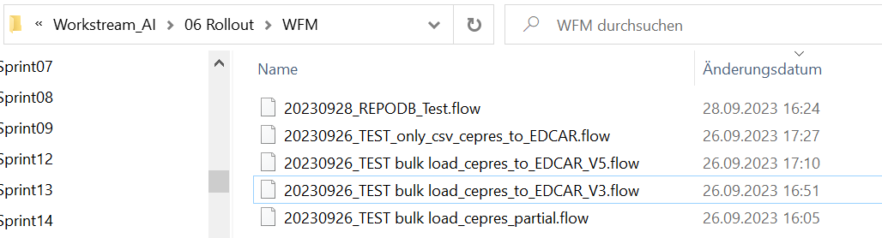

# Error Logs after Data Load

Each Data Flow produces a Data Load Report that includes a list of errors when loading data to DIZ. Specific errors should be investigated by EDCAR Team and fixed if possible.

1. REPODB:

Load Report with error list is generated based on below query:

$**Start_Timestamp**$' – replace with “Start” information in the report

'$**End_Timestamp**$ - replace with “End” in the report

**SELECT** format(lg.[load_ts],'yyyy-MM-dd HH:mm') **AS** LOAD_TS,lg.[JOB_ID],[SQL_PROC],[LOAD_ERROR_STATUS],[INFO],JOB_STATUS, SOURCE_ARGUMENTS  
**FROM** [TEST_EDCAR].[EDCAR].[SOURCE_LOAD_LOG] lg  
INNER JOIN [TEST_EDCAR].[EDCAR].[SOURCE_LOAD_JOB] jb **on** jb.JOB_ID=lg.JOB_ID  
INNER JOIN [TEST_EDCAR].dbo.TEST_fundlist ft **on** ft.FUND_ID=  
substring(SOURCE_ARGUMENTS, patindex('%>[A-Z|0-9][A-Z|0-9][A-Z|0-9][A-Z|0-9][A-Z|0-9][A-Z|0-9]<%',SOURCE_ARGUMENTS)+1, 6)  
**WHERE**  
        lg.[SOURCE_SYSTEM_ID] = 1 **AND**  
        format(lg.[load_ts],'yyyy-MM-dd HH:mm') >= '$Start_Timestamp$' **AND** format(lg.[load_ts],'yyyy-MM-dd HH:mm') <= '$End_Timestamp$' **AND**  
        [LOAD_ERROR_STATUS] = 1;

*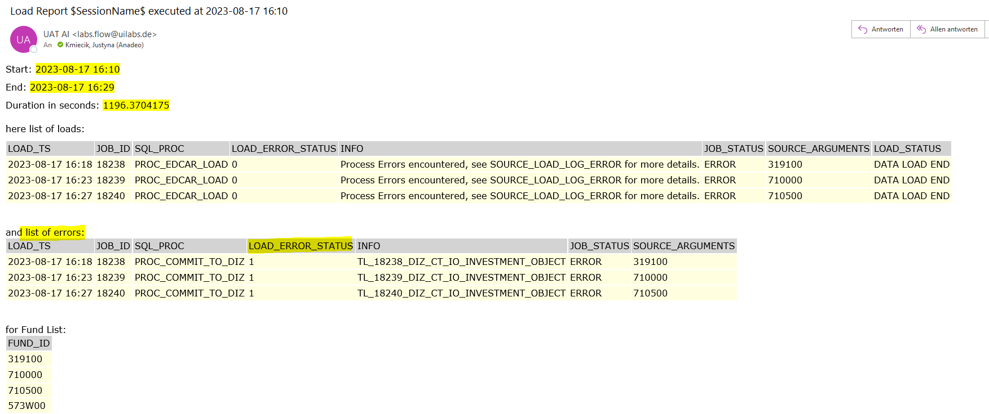Example of LOAD Report:*

1. CSV Bulk Load:

Load Report with error list is generated based on below query:

$**Start_Timestamp**$' – replace with “Start of Load” information in the report

'$**End_Timestamp**$ - replace with “End of Load” in the report

**SELECT** format(lg.[load_ts],'yyyy-MM-dd HH:mm') **AS** LOAD_TS,lg.[JOB_ID],[SQL_PROC],[INFO],JOB_STATUS,ERROR_MESSAGE,ERROR_INFO,SOURCE_ARGUMENTS,lg.LOAD_STATUS  
**FROM**   
[TEST_EDCAR].[EDCAR].[SOURCE_LOAD_LOG] lg  
INNER JOIN [TEST_EDCAR].[EDCAR].[SOURCE_LOAD_JOB] jb **on** jb.JOB_ID=lg.JOB_ID  
INNER JOIN [TEST_EDCAR].[EDCAR].[SOURCE_LOAD_LOG_ERROR] le **on** le.JOB_ID=lg.JOB_ID  
**WHERE**  
        lg.[SOURCE_SYSTEM_ID] = 2 **AND**  
        lg.[LOAD_STATUS] = 'DATA LOAD END' **AND**  
        JOB_STATUS='ERROR' **AND**  
        format(lg.[load_ts],'yyyy-MM-dd HH:mm') >= '$Start_Timestamp$' **AND** format(lg.[load_ts],'yyyy-MM-dd HH:mm') <= '$End_Timestamp$'  
**ORDER** **BY** JOB_ID **DESC**;

*Example of LOAD Report:*

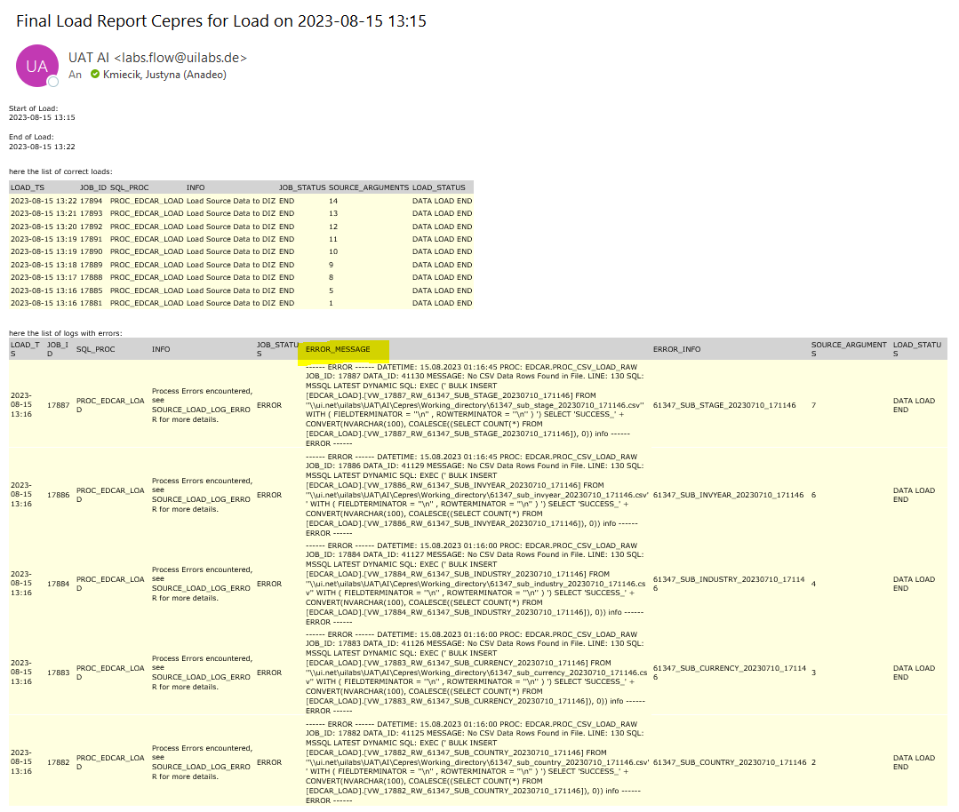

# List of Potential Errors in WFM & Solutions

|  |  |
| --- | --- |
| **Error Message** | **Solution** |
| Execution Timeout Expired | Check and adjust Server Timeout (go to **Global Management Items-> Databases**): |